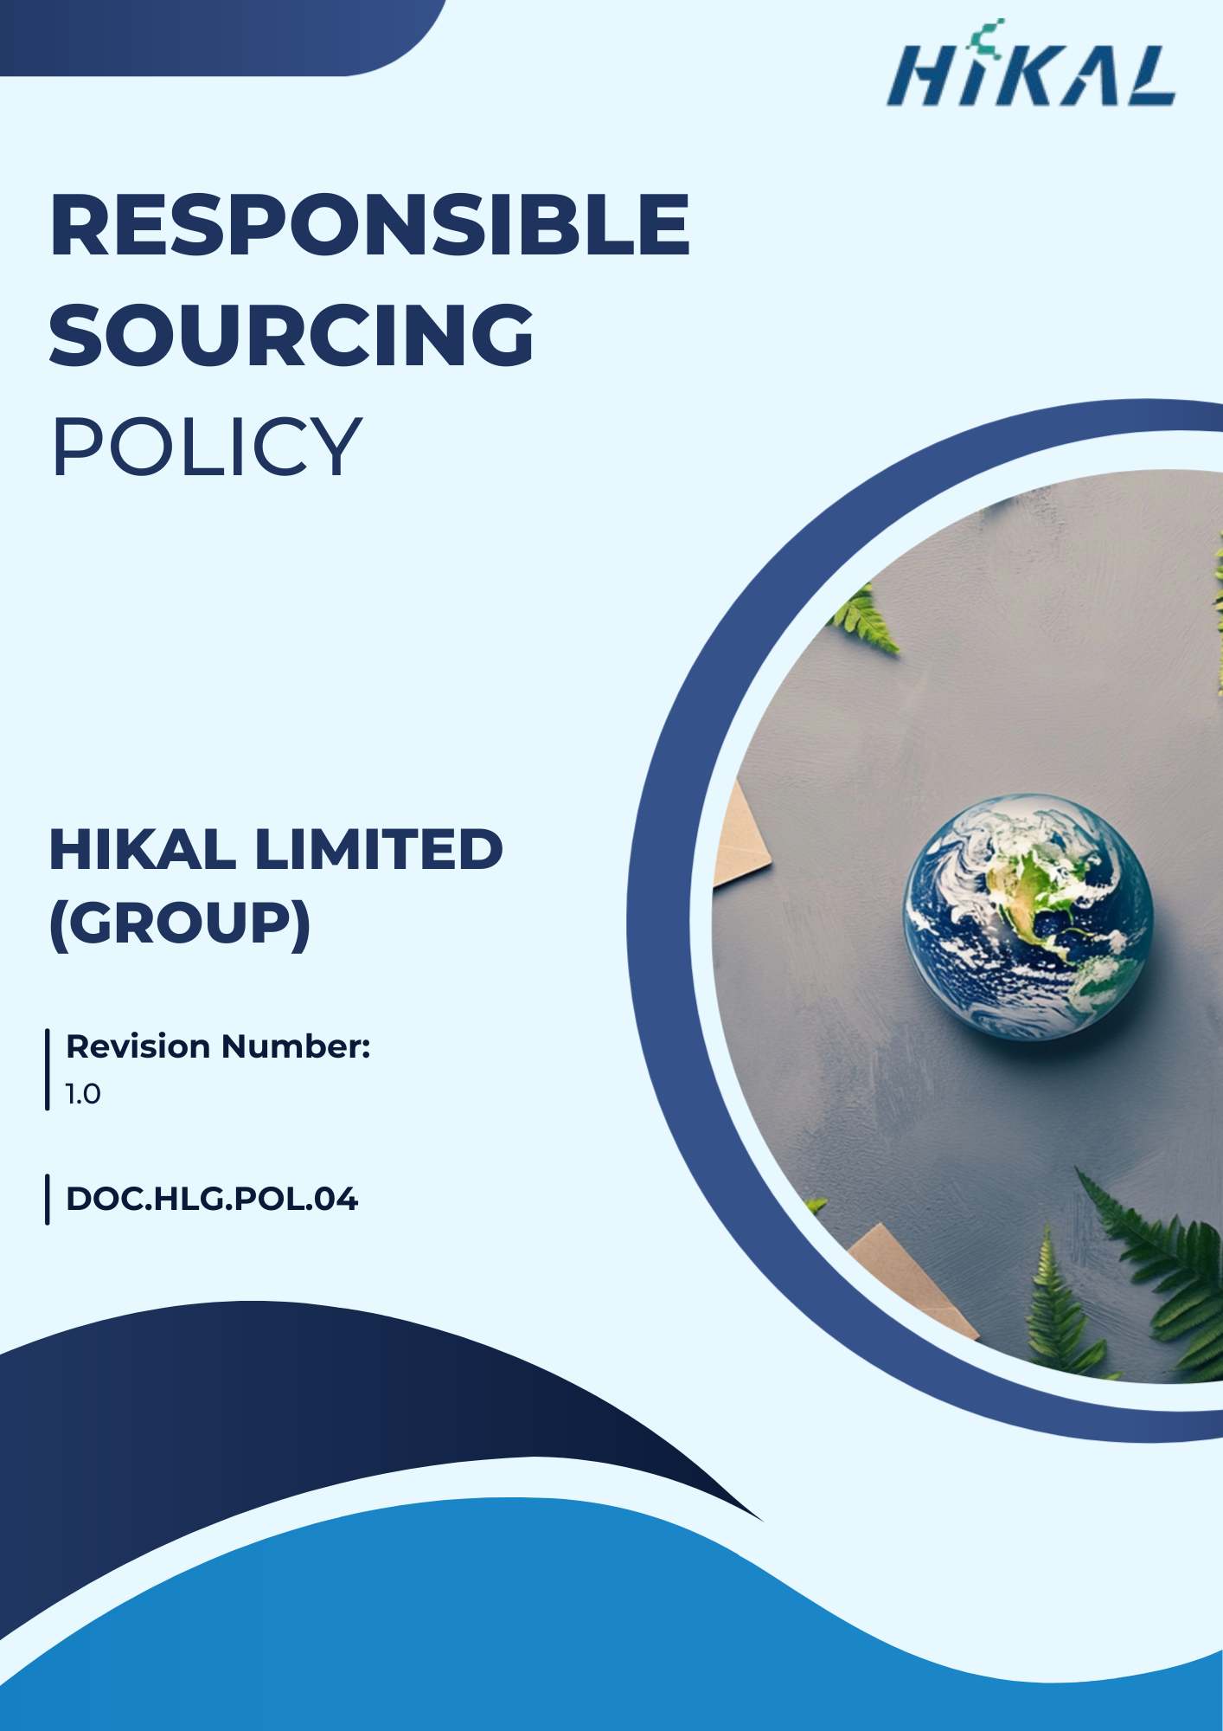

Version Control
Date | Revision Number | Comment
01st April 2025 | 00 | Initial Release
01st July 2025 | 1.0 | Updates in “Governance & Responsibility”
Next Review Date: 01st April 2026

Approved by
General Manager

Table of Contents
1. Preamble 4
2. Applicability 4
3. Focus Areas 5
4. Hikal’s Sourcing Commitments 5
5. Targets 7
6. Governance & Responsibility 9
7. Reporting & Monitoring 10
8. Continuous Improvement 10
9. Policy alignments with SDGs 10
10. Policy Review Mechanism 10

Preamble
The purpose of this Policy is to reaffirm and provide clear direction to Hikal Ltd.’s commitment to establishing and maintaining sustainable, ethical, and responsible business practices across its value chain. Through active collaboration with suppliers, vendors, contractors, and business partners, the Company seeks to integrate sustainability, integrity, and compliance into all purchasing and sourcing activities.

Applicability
Hikal Ltd. is committed to reducing the environmental impact of its supply chain by integrating sustainable practices in procurement, manufacturing, transportation, and disposal processes, in collaboration with both domestic and international suppliers. This Responsible Purchasing Policy applies to all employees, stakeholders, contractors, partners, customers, contract workers, and individuals representing the Hikal Limited Group, across all manufacturing units, operational facilities, offices, warehouses, and other premises owned, leased, or managed by the Group.
Sr. No. | Name | Function | Address
1 | Hikal Limited | Headquarter | Great Eastern Chambers, Sector 11, CBD Belapur, Navi Mumbai - 400 614, India.
2 | Hikal Limited | Manufacturing Plant | T-21, MIDC. Ind. Area, Taloja - 410 208, Dist Raigad, Maharashtra, India.
3 | Hikal Limited | Manufacturing Plant | A-18, MIDC Ind. Area, Mahad - 402 309, Dist. Raigad, Maharashtra, India.
4 | Hikal Limited | Manufacturing Plant | 629 / 630-B, GIDC Estate, Panoli -394 116, Dist. Bharuch, Gujarat, India.
5 | Hikal Limited | Manufacturing Plant | JIGANI UNIT I: 82/A, KIADB lnd. Area, Jigani, Anekal Taluk, Bangalore – 560 105, India.
6 | Hikal Limited | Manufacturing Plant | JIGANI UNIT II: 28, KIADB lndl. Area, Jigani, Anekal Taluk, Bangalore – 560 105, India.
7 | Hikal Limited | Research and Technology (R&T) Centres | Plot No. 3A & 3B, 2nd Phase, International Biotech Park, Hinjewadi,  Pune - 411 057, India.
8 | Hikal Limited | Research and Technology (R&T) Centres | 3rd floor, Grey Rock, No.10, 24th Main, J.P. Nagar, 2nd Phase, Bangalore - 560 078, India.
9 | Hikal Limited | Office | Kyodo Bldg. 503, 1-18 Kanda Sudacho,  Chiyoda-ku, Tokyo 101-0041, Japan.
10 | Hikal Limited | Office | Please mention office address of USA
11 | Hikal Limited | Office | Please mention office address of EUROPE

Focus Areas
- Ethical business conduct, including zero tolerance for bribery, corruption, fraud, and conflicts of interest.
- Respect for human rights and fair labor practices, including occupational health and safety, non-discrimination, and freedom of association.
- Environmental protection, including responsible resource use, waste management, emissions control, and pollution prevention.
- Management of social and environmental risks within the supply chain through supplier due diligence and transparency.
- Product quality, patient safety, and supply continuity to meet regulatory and customer requirements.
- Continuous improvement through supplier engagement, performance monitoring, and corrective action implementation.

Hikal’s Sourcing Commitments
- Goals for Procurement
  - We aim to collaborate with a recognized external sustainability rating agency to assess supplier sustainability performance and benchmark our supply chain against best-in-class practices, with assessment outcomes integrated into supplier performance reviews and improvement actions.
  - We aim to integrate sustainability considerations into all sourcing and procurement decisions by systematically evaluating environmental, social, and ethical risks across the supplier lifecycle.
  - We commit to ensuring that all suppliers formally acknowledge and comply with the Supplier Code of Conduct, covering ethical conduct, environmental responsibility, labor practices, and human rights.
  - We strive to encourage and influence suppliers to adopt responsible and sustainable practices, including improved energy efficiency, responsible resource use, and fair and ethical labor standards.
  - We will promote and implement digital and paperless procurement processes to minimize paper consumption and reduce the environmental impact of procurement operations.
  - We aim to build long-term, collaborative partnerships with suppliers to jointly develop sustainable solutions and facilitate the sharing of ESG best practices.
  - We commit to conducting periodic supplier self-assessments and risk-based audits of key suppliers to monitor ESG compliance, address identified gaps, and drive continuous improvement.
- Environmental issues associated with procurement
  - We aim to prioritize suppliers holding recognized environmental certifications, such as ISO 14001, EMAS, or equivalent standards, as a key criterion within our supplier pre-qualification and onboarding processes.
  - We aim to promote local and regional sourcing wherever feasible as a climate-mitigation measure to reduce transportation-related greenhouse gas (GHG) emissions across the supply chain.
  - We commit to integrating circular economy principles across our supplier base, encouraging practices related to waste reduction, recycling, and responsible material reuse.
  - We strive to encourage and support suppliers in transitioning toward renewable and clean energy sources for their operations and logistics activities.
  - We aim to source from suppliers that adopt environmentally responsible packaging solutions, including eco-friendly, recyclable, and biodegradable materials, wherever practicable.
  - We aim to strengthen internal procurement capabilities by providing periodic training and awareness programs to procurement personnel on environmental risks, impacts, and sustainability considerations associated with procurement and sourcing activities.
- Social Issues associated with procurement
  - We aim to integrate labor, human rights, and occupational health & safety certifications (e.g., ISO 45001, SA 8000, or equivalent social compliance standards) into supplier pre-qualification and risk screening processes to ensure responsible labor practices across our supply chain.
  - We aim to prioritize local and regional suppliers wherever feasible to support community development, enhance livelihoods, and reduce supply chain-related environmental impacts.
  - We commit to promoting supplier diversity through structured inclusion initiatives that encourage engagement with underrepresented, minority-owned, and small businesses.
  - We aim to prevent child labor, forced labor, and human trafficking across all tiers of the supply chain through supplier declarations, contractual commitments, and periodic monitoring.
  - We aim to strengthen internal procurement capabilities by providing periodic training and awareness programs to procurement personnel on labor, human rights, and social sustainability risks associated with sourcing activities.
- Governance issues associated with Procurement
  - We aim to ensure that all suppliers adhere to high standards of business ethics, anti-corruption, anti-bribery, and regulatory compliance through contractual commitments and supplier onboarding requirements.
  - We commit to conducting risk-based due diligence and periodic audits to monitor supplier adherence to governance standards, including ethical conduct, transparency, and anti-fraud measures.
  - We commit to promoting awareness and capacity building for procurement personnel on governance risks, ethical sourcing practices, and anti-corruption measures through periodic training programs.

Targets (referred company’s ASR 2024-25 and other provided documents)
- Goals for Procurement
  - We aim to ensure that 100% of suppliers read, acknowledge, and formally agree to the Supplier Code of Conduct by FY 2027-28 from the baseline of FY 2022-23.
  - We aim to assess at least 70% of suppliers annually on their environmental, social, and governance (ESG) performance by FY 2027-28 from the baseline of FY 2022-23.
  - We aim to ensure that at least 60% of assessed suppliers are compliant with our ESG requirements by FY 2027–28 from the baseline of FY 2022-23.
  - We commit to integrating sustainability criteria into 100% of procurement decisions by FY 2027-28.
  - We strive to ensure annual sustainability performance reporting for at least 50% of key suppliers by FY 2027-28.
- Environmental issues associated with procurement
  - We aim to train at least 80% of procurement personnel on environmental risks and impacts associated with procurement activities by FY 2027–28, using FY 2022–23 as the baseline.
  - We aim to achieve a 5% reduction in total supply chain greenhouse gas (GHG) emissions by FY 2027–28, compared to the FY 2022–23 baseline.
  - We plan to ensure that at least 15% of total procurement spend is sourced from suppliers holding ISO 14001, EMAS, or equivalent environmental certifications by FY 2027–28, from a FY 2022–23 baseline.
  - We aim to collect and monitor energy consumption and greenhouse gas (GHG) emissions data from at least 70% of suppliers by FY 2027–28, using FY 2022–23 as the baseline.
- Social Issues associated with procurement
  - We strive to increase procurement spend from suppliers holding recognized social and labor certifications by 10% by FY 2027–28, using FY 2022–23 as the baseline.
  - We aim to increase local and regional sourcing by at least 10% by FY 2027–28 to support regional economic development and improve community livelihoods, from a FY 2022–23 baseline.
  - We plan to train at least 80% of procurement personnel on labor standards, human rights risks, and responsible sourcing practices by FY 2027–28, with FY 2022–23 as the baseline.
  - We commit to resolving 100% of substantiated supply chain–related grievances within defined timelines by FY 2027–28, measured against a FY 2022–23 baseline.
- Governance issues associated with Procurement
  - We aim to ensure that 100% of active suppliers are screened for ethical risks, including corruption, bribery, fraud, and conflicts of interest, and that business relationships are maintained only with suppliers not associated with substantiated ethical violations by FY 2027–28, using FY 2022–23 as the baseline.
  - We aim to conduct business only with suppliers and business partners that demonstrate compliance with applicable laws and ethical standards and are not associated with substantiated cases of corruption, fraud, bribery, or other serious ethical misconduct by FY 2027–28, using FY 2022–23 as the baseline.

Governance & Responsibility
- Executive Management
  - Provides strategic direction and approves the Responsible Sourcing Policy.
  - Allocates resources for implementation, supplier assessments, and improvement initiatives.
  - Reviews overall performance and ensures alignment with ESG and business strategy.

- Head of Supply Chain
  - Review Responsible Procurement Policy Periodically
  - Holds overall accountability for policy execution across procurement activities.
  - Ensures sustainability criteria are embedded into supplier selection, contracts, and evaluations.
  - Oversees risk-based supplier segmentation and prioritization of high-risk suppliers.

- Procurement Managers & Buyers
  - Apply sustainability requirements during tendering, negotiations, and purchasing decisions.
  - Conduct supplier screening, collect documentation, and track corrective actions.
  - Engage suppliers on improvement plans and monitor progress through regular reviews.

- Quality Assurance (QA)
  - Ensures supplier practices align with GMP, quality standards, and regulatory obligations.
  - Participates in audits of critical suppliers and validates remediation activities.
  - Reviews supplier qualifications for materials impacting product quality or patient safety.

- All Employees Involved in Procurement Activities
  - Understand and follow this policy in daily decisions.
  - Report suspected violations

Reporting & Monitoring
Implementation of this Responsible Purchasing Policy is monitored through periodic supplier assessments, audits, and performance reviews. Key ESG indicators, compliance status, and progress against targets are reported internally to management on a regular basis and reviewed to identify gaps, corrective actions, and continuous improvement opportunities across the supply chain.

Policy alignments with SDGs


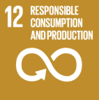

Policy Review Mechanism
This Responsible Purchasing Policy is reviewed at annually by Supply chain Head to assess its continued relevance, effectiveness, and alignment with applicable laws, regulatory requirements, and evolving ESG expectations. In addition, ad hoc reviews are conducted whenever there are significant regulatory changes, material supply chain risks, business expansions, or identified non-compliances, ensuring the policy remains current and responsive to emerging risks and stakeholder expectations.

